**Task#1: Inference Mapping**

**Topic Name: "The Impact of Climate Change on Global Food Security"**

**Reference Article:**

- "Climate Change and Food Security" by the Food and Agriculture Organization (FAO) of the United Nations

**Inference Report:**

The article highlights the significant impact of climate change on global food security. Rising temperatures, changing precipitation patterns, and increased frequency of extreme weather events are affecting agricultural productivity, food availability, and access to food.

**Key inferences:**

1. Climate change is projected to decrease global food production by 2% per decade.

2. Changes in temperature and precipitation patterns are altering the distribution and prevalence of crop and animal pests and diseases.

3. Climate-related shocks, such as droughts and floods, can lead to food price volatility and increased malnutrition.

4. Small-scale farmers, particularly in developing countries, are disproportionately affected by climate change due to limited resources and infrastructure.

5. Climate-resilient agriculture practices, such as agroforestry and conservation agriculture, can help mitigate the impacts of climate change on food security.

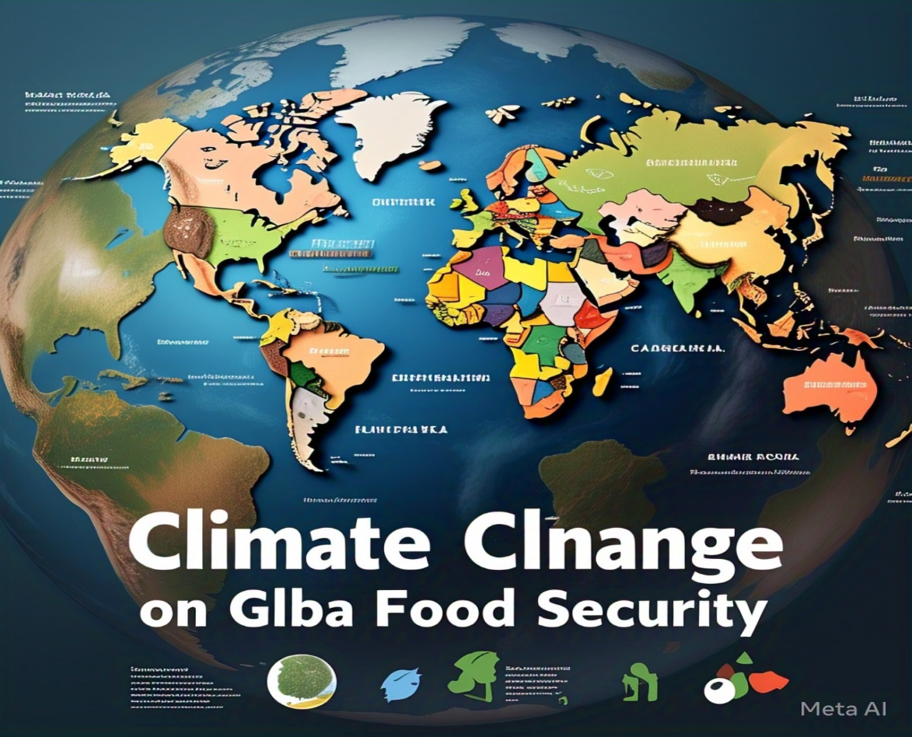

**Task #2: Waterfall Model and product development**

**Topic Name:**

**Waterfall Development Model for a To-Do List App**

**Step-by-Step Process:**

**Step 1: Preview the Premium Waterfall Project Methodology Template**

* Open Lucidchart and search for the premium waterfall project methodology template.
* Review its structure, key stages, and flow to understand the premium features.
* Take notes on the essential components and how the flow is organized.

**Step 2: Create Your Own Waterfall Development Model**

1. Requirements Gathering and Analysis
   * Gather detailed requirements from stakeholders.
   * Document all specifications and features required for the To-Do List App (e.g., task creation, due dates, reminders**,** categorization).
2. **System Design**
   * Design the system architecture, including the user interface and backend database.
   * Create detailed design documents outlining the app’s structure and interactions**.**
3. **Implementation (Coding)**
   * Develop the software application based on the design documents.
   * Write code for various modules, including user authentication, task management, and notifications.
4. **Integration and Testing**
   * Integrate all components and modules.
   * Conduct thorough testing to ensure the app functions as expected.
   * Perform unit testing, integration testing, and system testing.
5. **Deployment**
   * Deploy the To-Do List App to the production environment (e.g., app store, web server).
   * Ensure all components are correctly installed and configured.
6. **Maintenance**
   * Provide ongoing support and maintenance.
   * Address any bugs or issues that arise post-deployment.
   * Implement updates and improvements as needed.

**Task #3: Stakeholder Mapping**

**Topic :**

Stakeholder Mapping for the Development of a To-Do List App

**Stakeholder Mapping for To-Do List App**

**Categories of Stakeholders:**

1. Primary Stakeholders:
   * Project Manager: Oversees the project and ensures it stays on track.
   * Development Team: Responsible for coding, testing, and implementing the app.
   * UX/UI Designers: Design the user interface and user experience.
   * Quality Assurance (QA) Testers: Test the app for bugs and usability issues.
2. Secondary Stakeholders:
   * Marketing Team: Promotes the app and creates marketing campaigns**.**
   * Support Team: Provides customer support and handles user feedback.
   * Sales Team: Responsible for monetization and revenue generation.
   * Product Owners: Define the product vision and ensure it aligns with business goals**.**
3. **Tertiary Stakeholders:**
   * End Users: The target audience who will use the app.
   * Investors: Provide funding and expect a return on investment.
   * Partners: Collaborate on the project and may offer integration opportunities.
   * Regulators: Ensure the app complies with relevant laws and regulations.

**Stakeholder Mapping Diagram:**

1. Identify Stakeholders: List all the stakeholders identified above.
2. Categorize Stakeholders: Group them into primary, secondary, and tertiary stakeholders.
3. Map Relationships: Draw connections between stakeholders to show interactions and dependencies**.**

* Use lines or arrows to connect stakeholders, showing their relationships and interactions.

**Task #4: Journey mapping**

**Topic Name:**

User Research and Persona Creation for a Smart Home Lighting System

**1. User Research:**

* Product: Smart Home Lighting System
* Method: Surveys and interviews with 150 participants
* Purpose: Understand user preferences, challenges, and behaviors related to home lighting

**2. Persona Creation:**

Persona Name: John Thompson

Demographic Information:

* Name: John Thompson
* Age: 35
* Occupation: Software Developer
* Education: Bachelor’s Degree in Computer Science
* Income: $80,000 per year
* Location: San Francisco, USA
* Family: Married with two children

**Goal and Objectives:**

* Primary Goal: Automate home lighting to enhance convenience and energy efficiency
* **Objectives:**
  + Control lighting remotely
  + Schedule lighting to match daily routines
  + Reduce energy consumption and electricity bills

**Psychographic Information:**

* Interests: Technology, smart home devices, environmental sustainability
* Values: Efficiency, innovation, and eco-friendliness
* Personality Traits: Tech-savvy, detail-oriented, and environmentally conscious

**Behavior and Preference:**

* Behaviors:
  + Regularly explores new smart home technologies
  + Prefers products with user-friendly interfaces
  + Seeks recommendations from tech blogs and forums
* Preferences:
  + Prefers devices that integrate seamlessly with existing smart home systems
  + Values products with energy-saving features

**User Journey:**

1. Discovery: John reads tech blogs and watches product reviews to learn about smart lighting systems.
2. Consideration: He compares different smart lighting options and reads user reviews.
3. Usage: John uses the smartphone app to control and schedule his lights, creating customized lighting scenes.
4. Satisfaction: He enjoys the convenience and energy savings, and shares his positive experience with friends and family.

**Challenges and Pain Points:**

* Initial setup complexity
* High initial cost of smart lighting systems
* Integrating new devices with existing smart home infrastructure

**3. Journey Mapping:**

* Stages: Discovery, Consideration, Purchase, Setup, Usage, Satisfaction
* User Actions: Reading blogs, comparing options, buying online, installing, using the app, sharing experience
* Pain Points: Setup complexity, initial cost, integration issues
* Emotions: Excitement, frustration, satisfaction, pride

**Task #5: Inference Mapping**

**Topic Name: "The Impact of Artificial Intelligence on Job Markets"**

**Reference Article:**

**- "**The Future of Jobs Report 2020" by the World Economic Forum

**Inference Report:**

The article highlights the significant impact of artificial intelligence (AI) on job markets worldwide. The report predicts that by 2025, AI will displace 85 million jobs globally, while creating 97 million new roles.

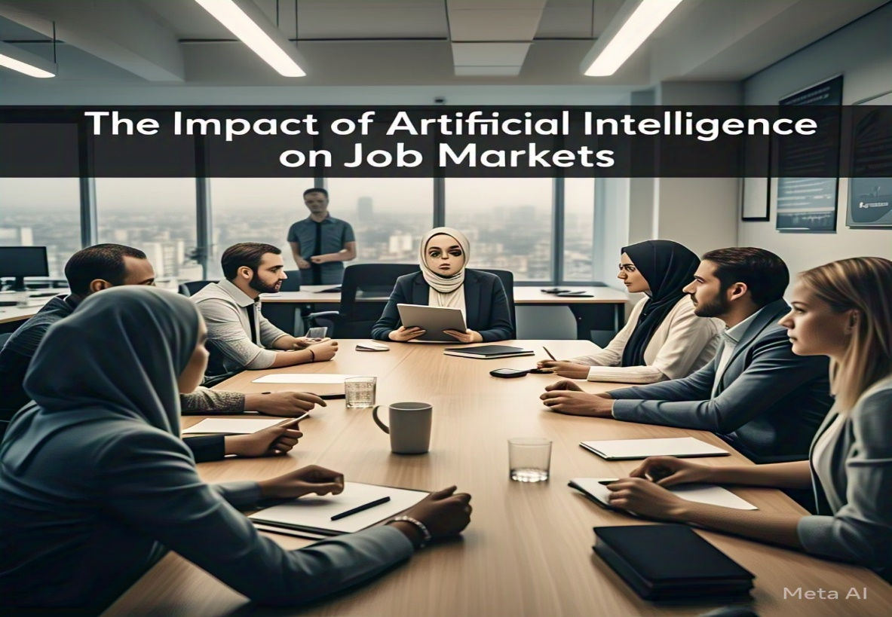

**Key inferences:**

**1**. AI will disproportionately affect certain industries, such as data entry, customer service, and bookkeeping.

2. Emerging technologies like AI, robotics, and blockchain will create new job opportunities in fields like data science, AI development, and cybersecurity.

3. The report emphasizes the need for workers to develop skills that are complementary to AI, such as critical thinking, creativity, and emotional intelligence.

**4.** Governments and businesses must invest in retraining and upskilling programs to prepare workers for the changing job market.

5. The future of work will require a shift towards lifelong learning, with workers needing to continually update their skills to remain relevant.

Overall, the article highlights the need for proactive measures to mitigate the negative impacts of AI on job markets and to prepare workers for the changing landscape.

**Task #6: User Journey Map**

**Topic :**

User Journey Map for the Samsung 2024 AI-Fridge

**User Actions, Emotions, and Pain Points:**

1. Awareness:
   * + Reads tech blogs and articles about the latest smart home appliances.
     + Excitement about the new technology.
     + Curiosity about the features and benefits.
     + Uncertainty about the reliability of new technology.
2. **Consideration:**
   * + Compares different smart fridge models and brands.
     + Reads user reviews and ratings on e-commerce websites.
     + Visits the official Samsung website to explore detailed features.
     + Concern about the price and installation process.
     + Worry about the compatibility with existing smart home devices.
3. **Purchase:**
   * + Adds the AI-Fridge to the cart on an e-commerce platform.
     + Looks for discounts, offers, and financing options.
     + Completes the purchase online or visits a physical store.
     + Anxiety about the delivery and installation process.
     + Uncertainty about the return and warranty policies.
4. **Setup:**
   * + Receives the AI-Fridge and schedules installation.
     + Connects the fridge to the SmartThings app.
     + Relief once the setup is complete.
     + Difficulty in understanding the setup instructions.
     + Frustration if there are connectivity issues.
5. **Usage:**
   * + Sets up custom cooling modes and energy-saving settings.
     + Receives notifications about maintenance and energy usage.
     + Satisfaction with the convenience and smart features.
     + Confidence in the energy-saving capabilities.
     + Occasional glitches or app crashes.

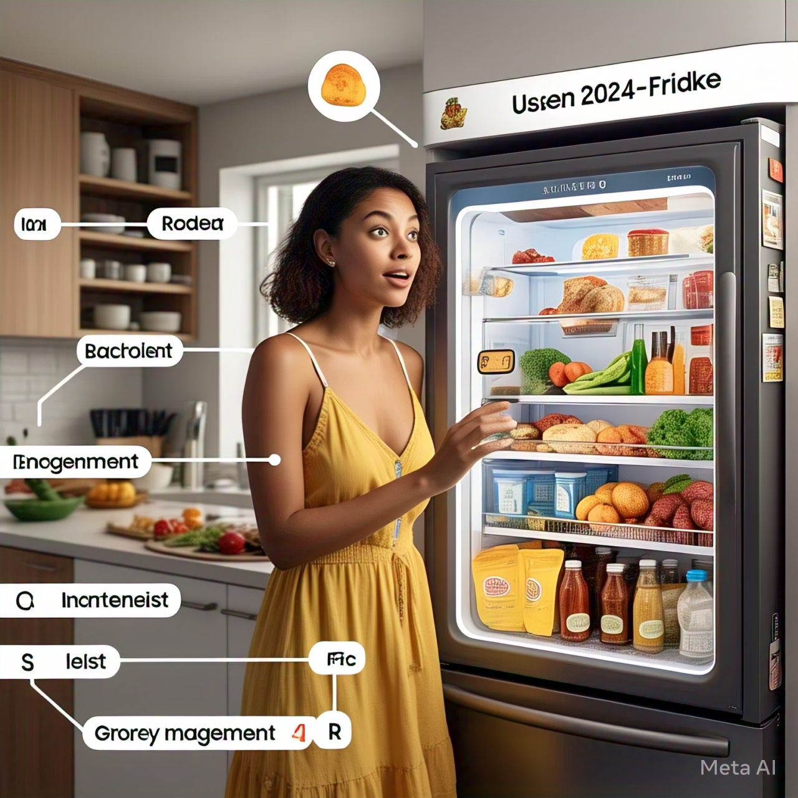

1. **Maintenance:**
   * + Regularly cleans and maintains the fridge.
     + Contacts customer support for any issues.
     + Trust in the product's durability and support.
     + Inconvenience if there are any technical issues.
     + Cost of maintenance and repairs.

**Task #7: Complex Problem Table**

**Topic:**

**Complex Problem Analysis in Various Application Domains**

**Complex problem table:**

| **Application Domain** | **Complex Problem Identified** | **Justification** |
| --- | --- | --- |
| **Healthcare** | Optimizing Patient Scheduling | Scheduling patients efficiently to minimize wait times while maximizing the utilization of medical resources. |
| **Urban Transportation** | Traffic Congestion Management | Developing systems to monitor, predict, and manage traffic flow to reduce congestion and improve travel times. |
| **Financial Services** | Fraud Detection in Online Transactions | Identifying and preventing fraudulent activities in real-time to safeguard user accounts and transactions. |

**Task #8: Gap Analysis**

**Topic:**

**Gap Analysis for Saffola**

**Gap analysis:**

| **Aspect** | **Current State** | **Desired State** | **Gap** |
| --- | --- | --- | --- |
| Product Variety | Limited range of health food options | Diverse and innovative health food products | Need to expand the product line to include more health food options |
| Market Reach | Strong presence in urban areas | Strong presence in both urban and rural areas | Need to strengthen market presence in rural areas |
| Pricing | Premium pricing | Affordable pricing without compromising quality | Need to make products more accessible and affordable |
| Brand Perception | Known for heart-healthy cooking oils | Comprehensive health and wellness brand | Need to position Saffola as a holistic health and wellness brand |
| Customer Engagement | Loyal customer base | Attract new customers and retain existing ones | Need to enhance customer engagement and attract a broader audience |



• **Product Variety:**

* Research and develop new health food products that cater to emerging trends and dietary preferences.
* Introduce innovative products such as plant-based proteins, superfoods, and functional beverages.

•

**Task #9: Empathy Process Flow**

**Topic :**

**Empathy Process Flow for a Smart Thermostat**

**Empathy Process Flow:**

**Step 1: Identify and Fix the Product**

We'll work on a Smart Thermostat. This product helps users control their home heating and cooling systems remotely, learn their schedules, and optimize energy usage.

**Step 2: Explore its Features**

1. Remote Control: Control the thermostat using a smartphone app.
2. Learning Ability: Learns user schedules and preferences to adjust temperature automatically.
3. Energy Reports: Provides reports on energy usage and savings.
4. Voice Control: Integrates with voice assistants like Alexa, Google Assistant, etc.
5. Geo-fencing: Adjusts temperature based on user location.

**Step 3: Prepare an Empathy Process Flow using an Empathy Map Template**

**User Persona: Alex**

* **Age:** 35
* **Occupation:** Software Engineer
* **Lifestyle:** Tech-savvy, eco-conscious, values convenience

**Goals:**

* Efficiently manage home temperature
* Save on energy bills
* Control thermostat remotely

**Thoughts:**

* “I want my home to be comfortable when I arrive.”
* “It’s important to reduce my energy consumption.”
* “I like using technology to simplify my life.”

**Feelings:**

* Frustration: When the thermostat doesn’t respond correctly
* Satisfaction: When energy bills decrease
* Comfort: When the home is at the perfect temperature upon arrival

**Pain Points:**

* Difficult setup process
* Inconsistent app performance
* High initial cost

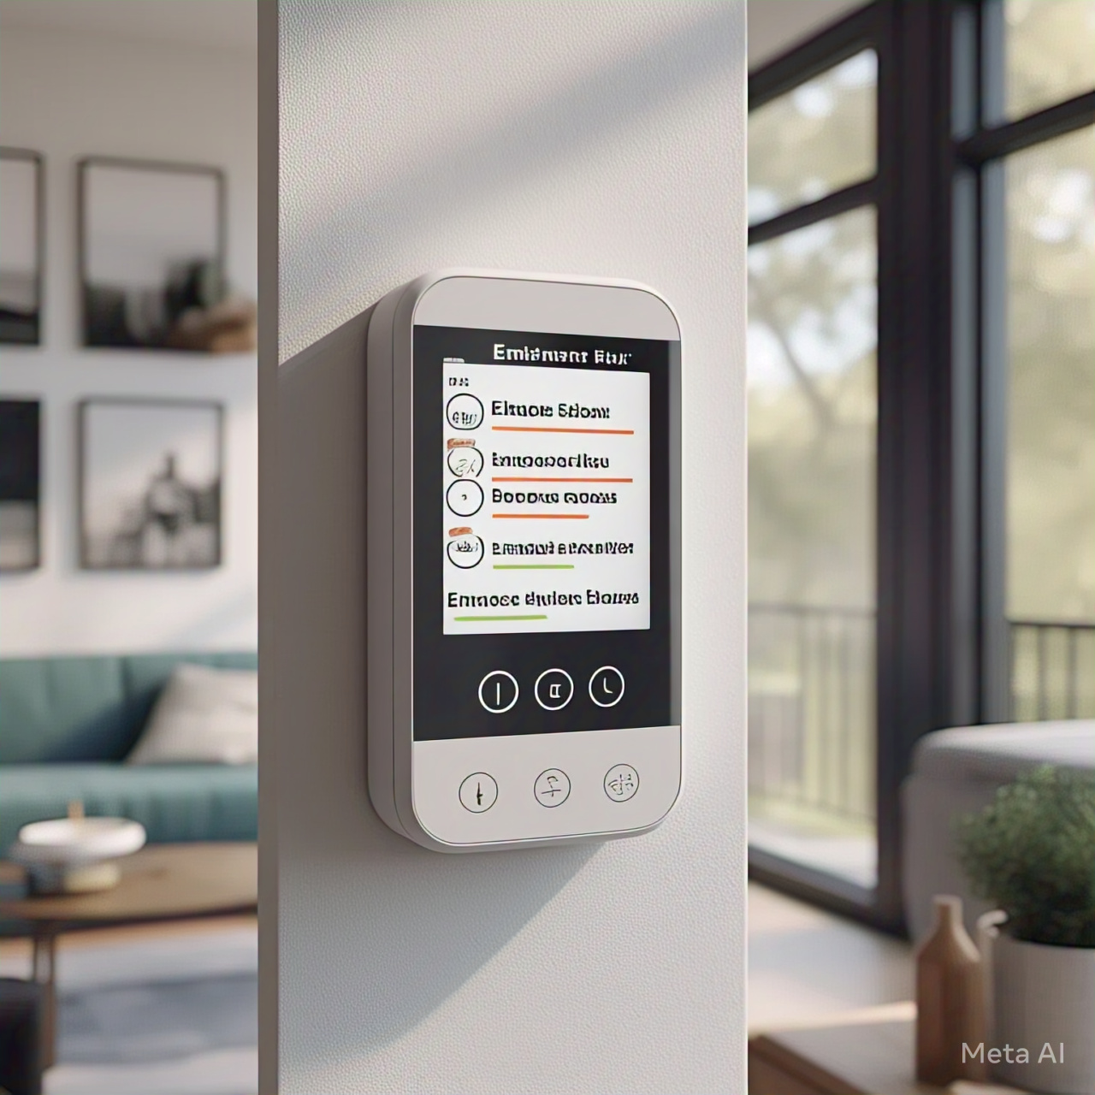

**Actions:**

* Regularly checks the app for temperature adjustments
* Reviews energy usage reports monthly
* Uses voice commands to control the thermostat

**Task #10: Extempore Activity**

**Topic:**

**The Impact of IT in Various Industries**

**Extempore topics:**

**IT in Automobile**

Information Technology (IT) has revolutionized the automobile industry. Modern cars are now equipped with advanced driver-assistance systems (ADAS) that use AI to provide features like adaptive cruise control and automated parking. Self-driving cars are becoming a reality, thanks to IT. Cars can also connect to the internet and other devices, allowing for real-time navigation, entertainment, and maintenance alerts. These advancements make driving safer, more efficient, and enjoyable. Imagine a future where your car can drive you to work while you relax and enjoy the ride!

**IT in Metro Rail**

IT has significantly improved metro rail systems, making urban transportation more efficient and reliable. Smart signaling systems control train movements automatically, reducing delays and enhancing safety. Passengers receive real-time updates on train schedules and any service disruptions, thanks to IT. Automated fare collection systems make ticketing easy and error-free. IT also plays a crucial role in maintenance by monitoring the condition of trains and tracks, ensuring timely repairs. With IT, metro travel has become smoother, faster, and more convenient for millions of people.

**IT in Avionics**

In the aviation industry, IT has made flights safer and more efficient. Modern aircraft are equipped with advanced computer systems that assist pilots in navigation and communication. These systems optimize flight routes, saving fuel and time. IT also helps monitor the aircraft's condition, allowing for predictive maintenance and reducing the risk of unexpected failures. Passengers benefit from better in-flight entertainment and personalized services. IT has truly transformed the aviation industry, ensuring safer skies and a more enjoyable flying experience for everyone.